Functionality
Logistics Invoice Verification is a part of Materials Management (MM). It is situated at the end of the logistics supply chain that includes Purchasing, Inventory Management, and Invoice Verification. It is in Logistics Invoice Verification that incoming invoices are verified in terms of their content, prices, and arithmetic. When the invoice is posted, the invoice data is saved in the system. The system updates the data saved in the invoice documents in Materials Management and Financial Accounting.

Scenario
This process is the classic method used to verify invoices:
You enter the data from the vendor invoice in the system.
As you do this, you compare the data with the suggested quantities and values for each item. If differences occur, you make any necessary corrections. You then can post the invoice

Requirements
Purchase order and Goods Receipt

Menu Path | Logistics → Materials Management → Logistics Invoice Verification → Document Entry → MIRO - Enter Invoice
Transaction Code | MIRO

1. Double click on MIRO - Enter Invoice.

Enter Invoice: Company Code 5200

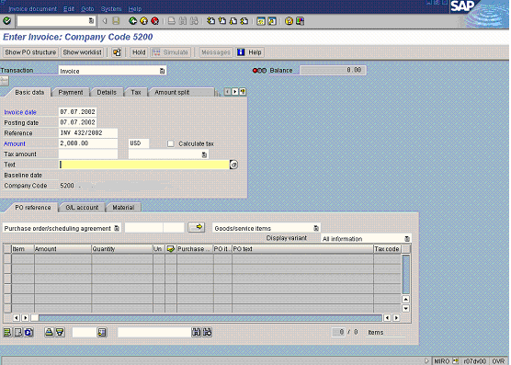

2. Update the following fields:

Field Name | Field Description | Values
Invoice date | Date when the invoice was issued | Example: 070702
Reference | The reference document number is used as a search criterion when displaying or changing documents. Usually enter here the document number of the vendor | Example: INV 432/2002
Amount | Amount of the line item | Example: 2000

3. You need to enter a purchase order that corresponds with this invoice. Click Purchase order/scheduling agreement Button .
4. Enter your search criteria:

Possible Entries for Purchasing Document

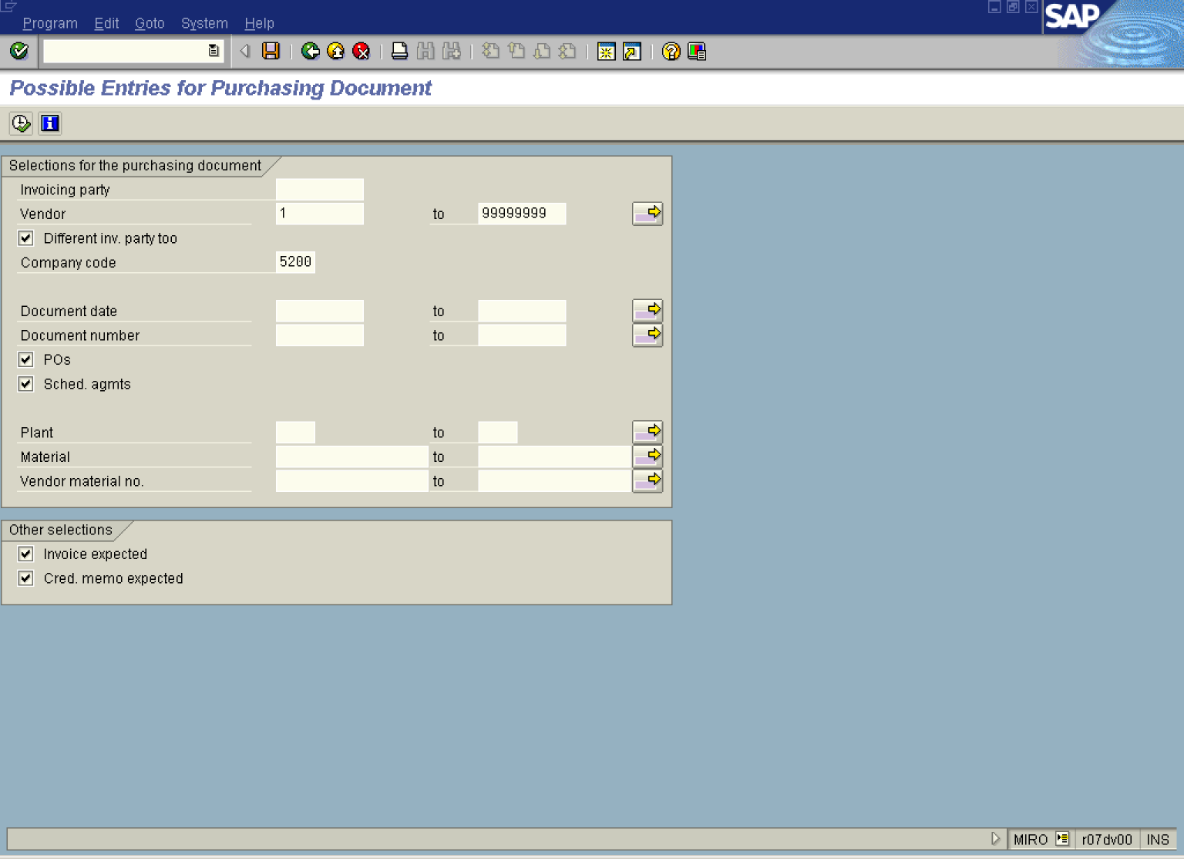

5. Update the following fields:

Field Name | Field Description | Values
Vendor | Code identifying the vendor account | Example: 1
to |  | Example: 99999999

6. Click Execute to display purchase orders:

Possible Entries for Purchasing Document (48 selected)

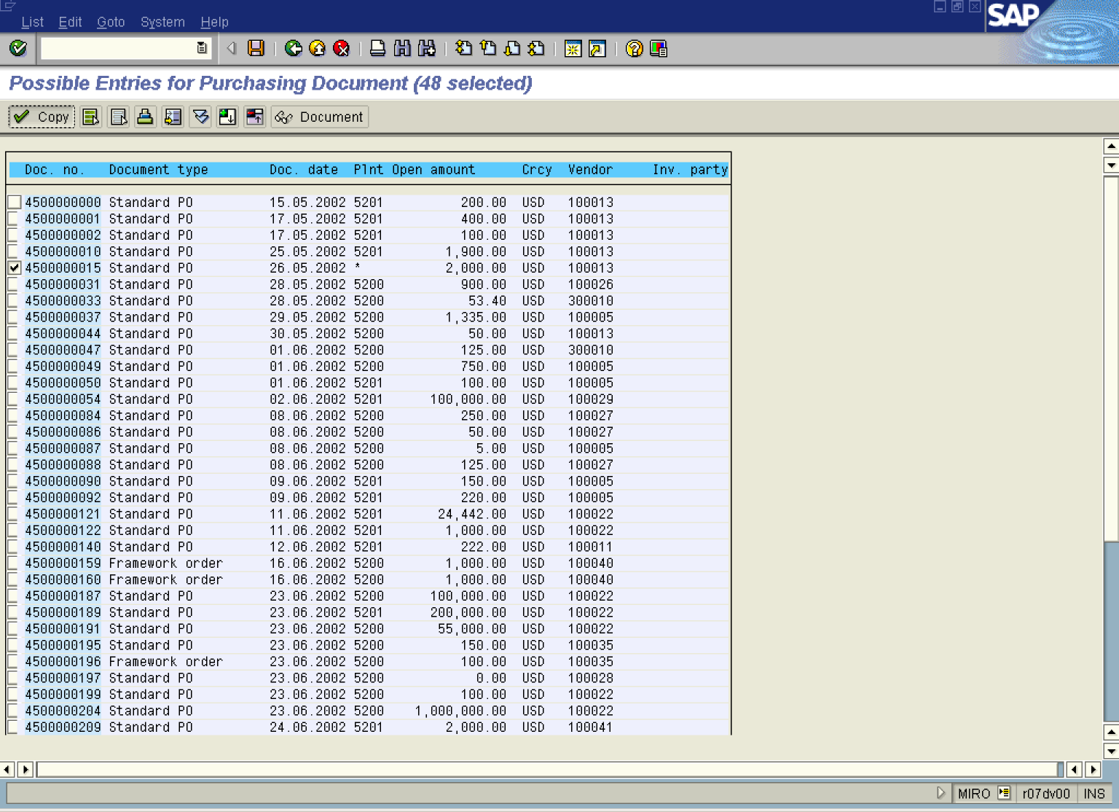

7. Click on the selected purchase order, e.g. 4500000015 Standard PO .

8. Click Copy Button to choose this purchase order to be processed.

Enter Invoice: Company Code 5200

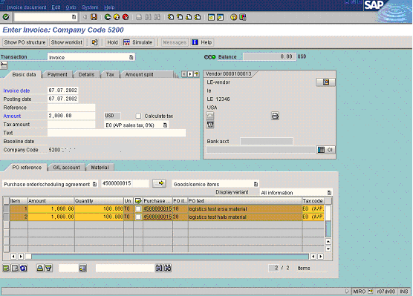

9. Click <tab button> Payment to enter the payment data.

Enter Invoice: Company Code 5200

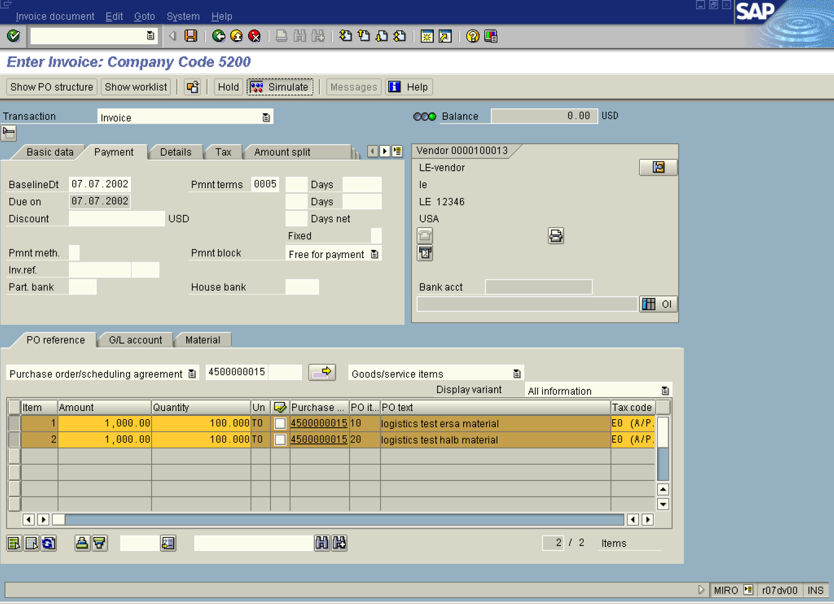

10. Update the following fields:

Field Name | Field Description | Values
BaselineDt | Date to which the periods for the cash discount deadline and the due date for net payment refer. | Example: 070702

11. Click Simulate Button .

Simulate Document in USD (Document currency)

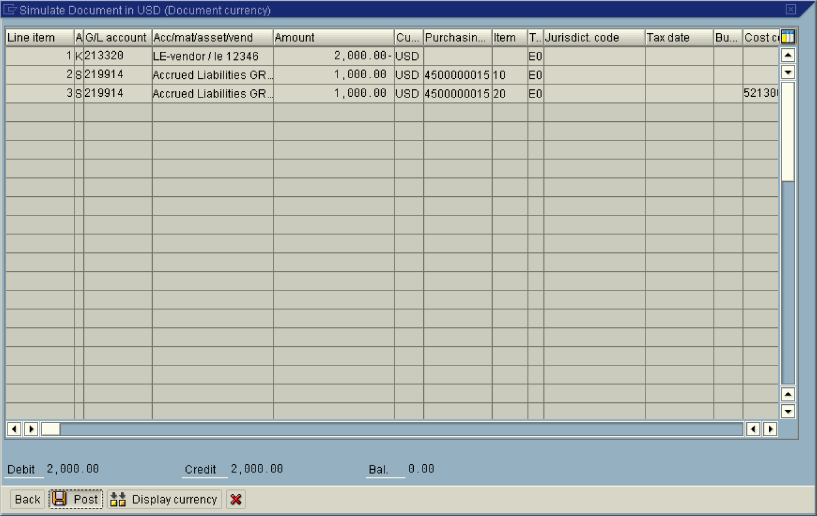

12. To post the vendor invoice, click Post Button .

13. The message bar displays “Document no. XXXXXXX created”.

 The system updated also GL and Vendor accounts. You can display this invoice e.g. using transaction FB03 or report FBL1N

